**DA-100**

**QUESTION 1**

**Note: This question is part of a series of questions that present the same scenario. Each question in the series contains a unique solution that might meet the stated goals. Some question sets might have more than one correct solution, while others might not have a correct solution.**

**After you answer a question in this section, you will NOT be able to return to it. As a result, these questions will not appear in the review screen.**

You have a Power BI model that contains two tables named Sales and Date. Sales contains four columns named TotalCost, DueDate, ShipDate, and OrderDate. Date contains one column named Date.

The tables have the following relationships:

Sales[DueDate] and Date[Date] Sales[ShipDate] and Date[Date] Sales[OrderDate] and Date[Date]

The active relationship is on Sales[DueDate].

You need to create measures to count the number of orders by [ShipDate] and the orders by [OrderDate]. You must meet the goal without duplicating data or loading additional data.

Solution: You create a calculated table. You create a measure that uses the new table. Does this meet the goal?

1. Yes
2. No

## Correct Answer: B Section: (none) Explanation

**Explanation/Reference:**

**QUESTION 2**

**Note: This question is part of a series of questions that present the same scenario. Each question in the series contains a unique solution that might meet the stated goals. Some question sets might have more than one correct solution, while others might not have a correct solution.**

**After you answer a question in this section, you will NOT be able to return to it. As a result, these questions will not appear in the review screen.**

You have a Power BI model that contains two tables named Sales and Date. Sales contains four columns named TotalCost, DueDate, ShipDate, and OrderDate. Date contains one column named Date.

The tables have the following relationships:

Sales[DueDate] and Date[Date] Sales[ShipDate] and Date[Date] Sales[OrderDate] and Date[Date]

The active relationship is on Sales[DueDate].

You need to create measures to count the number of orders by [ShipDate] and the orders by [OrderDate]. You must meet the goal without duplicating data or loading additional data.

Solution: You create measures that use the CALCULATE, COUNT, and FILTER DAX functions. Does this meet the goal?

1. Yes
2. No

## Correct Answer: A

## QUESTION 3

**Note: This question is part of a series of questions that present the same scenario. Each question in the series contains a unique solution that might meet the stated goals. Some question sets might have more than one correct solution, while others might not have a correct solution.**

**After you answer a question in this section, you will NOT be able to return to it. As a result, these questions will not appear in the review screen.**

You have a Power BI model that contains two tables named Sales and Date. Sales contains four columns named TotalCost, DueDate, ShipDate, and OrderDate. Date contains one column named Date.

The tables have the following relationships:

Sales[DueDate] and Date[Date] Sales[ShipDate] and Date[Date] Sales[OrderDate] and Date[Date]

The active relationship is on Sales[DueDate].

You need to create measures to count the number of orders by [ShipDate] and the orders by [OrderDate]. You must meet the goal without duplicating data or loading additional data.

Solution: You create two copies of the Date table named ShipDate and OrderDateGet. You create a measure that uses the new tables. Does this meet the goal?

1. Yes
2. No

## Correct Answer: B

**QUESTION 4**

You plan to embed multiple visualizations in a public website.

Your Power BI infrastructure contains the visualizations configured as shown in the following table.

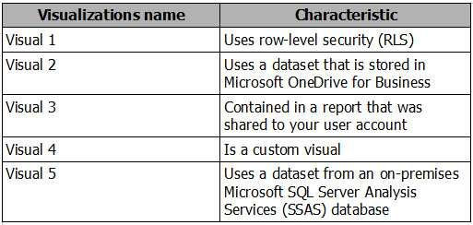

Which two visualizations can you embed into the website? Each correct answer presents a complete solution.

**NOTE:** Each correct selection is worth one point.

1. Visual 1
2. Visual 2
3. Visual 3
4. Visual 4
5. Visual 5

## Correct Answer: BD

## QUESTION 5

You create a report in the Power BI service that displays the following visualizations:

A KPI that displays the count of customers

A table that displays the count of customers by country A line chart that displays the count of customers by year

You need to receive an alert when the total number of customers reaches 10,000. What should you do first?

1. Pin the line chart to a dashboard.
2. Pin the KPI to a dashboard.
3. Embed the report into a Microsoft SharePoint page.
4. Pin the report to a dashboard.

## Correct Answer: D

## QUESTION 6

You have a Power BI dashboard that displays different visualizations of company sales. You enable Q&A on the dashboard.

You need to provide users with sample questions that they can ask when using Q&A. Which settings should you modify form the Power BI Settings?

1. Subscriptions
2. Workbooks
3. Dashboards
4. Datasets

## Correct Answer: D

## QUESTION 7

You have an app workspace named Retail Store Analysis in the Power BI service.

You need to manage the members that have access to the app workspace using the least amount of administrative effort. What should you do?

1. From the Office 365 Admin center, click **Users**.
2. From the Power BI Admin portal, click **Tenant settings**.
3. From the Power BI Admin portal, click **Usage metrics**.
4. From the Office 365 Admin center, click **Groups**.

## Correct Answer: D

## QUESTION 8

You are creating a report in Power BI Desktop. You are consuming the following tables.

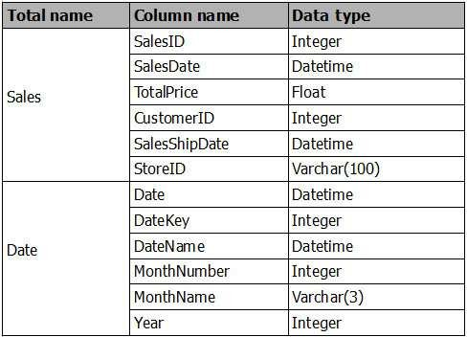

You have a new table named Fiscal that has the same schema as the Date table, but contains the fiscal dates of your company. You need to create a report that displays the total sales by fiscal month and calendar month.

What should you do?

1. Union Fiscal and Date as one table.
2. Add Fiscal to the model and create a one-to-many relationship by using Date[Year] and Fiscal[Year].
3. Add Fiscal to the model and create a one-to-one relationship by using Date[Year] and Fiscal[Year].
4. Merge Fiscal into the Date table.

## Correct Answer: D

## QUESTION 9

You use Power BI Desktop to create a visualization for a Microsoft SQL Server data source. You need to ensure that you can use R visualization.

Which two actions should you perform? Each correct answer presents part of the solution.

**NOTE:** Each correct selection is worth one point.

1. Download and install Microsoft R Server.
2. Download and install RStudio Server on the computer that has Power BI Desktop installed.
3. Install SQL Server R Services on the server that runs SQL Server.
4. Enable R Scripting on the computer that has Power BI Desktop installed.
5. Download and install Microsoft R on the computer that has Power BI Desktop installed.

## Correct Answer: E

## QUESTION 10

You have a Power BI model that contains the following two tables:

Sales(Sales_ID, sales_date, sales_amount, CustomerID) Customer(CustomerID, First_name, Last_name)

There is a relationship between Sales and Customer.

You need to create a measure to rank the customers based on their total sales amount. Which DAX formula should you use?

1. RANKX(ALL(Sales), SUMX(RELATEDTABLE(Customer), [Sales_amount]))
2. TOPN(ALL(customer), SUMX(RELATEDTABLE(Sales), [Sales_amount]))
3. RANKX(ALL(customer), SUMX(RELATEDTABLE(Sales), [Sales_amount]))
4. RANK.EQ(Sales[sales_amount], Customer[CustomerID])

## Correct Answer: A

## QUESTION 11

You plan to deploy a Power BI app workspace that will be viewed by 10,000 users. You need to ensure that dashboard data can be updated every 30 minutes.

What should you do?

1. Assign each user a Power BI Pro license.
2. Store the dataset in Microsoft Azure Storage that uses the Premium storage tier.
3. Create the app workspace by using an account that is assigned a Power BI Pro license.
4. Configure the app workspace for Premium capacity.

## Correct Answer: D

## QUESTION 12

You have a Microsoft Excel 2016 workbook that has a Power Pivot model. The model contains the following tables:

Product (Product_id, Product_Name)

Sales (Order_id, Order_Date, Product_id, Salesperson_id, Sales_Amount) Salesperson (Salesperson_id, Salesperson_name, address)

The model has the following relationships:

Sales to Product Sales to Salesperson

You create a new Power BI file and import the Power Pivot model.

You need to ensure that you can generate a report that displays the count of products sold by each salesperson. What should you do before you create the report?

1. Create a one-to-one relationship between Product and Salesperson.
2. For each relationship, change the Cross filter direction to **Both**.
3. For each relationship, change the Cardinality to **One to one (1:1)**.
4. Change a many-to-one relationship between Product and Salesperson.

## Correct Answer: B

## QUESTION 13

You have a Power BI model that contains the following two tables:

Sales (Sales_ID, DateID, sales_amount) Date(DateID, Date, Month, Week, Year)

The tables have a relationship.

You need to create a measure to calculate the sales for same period from the previous year. Which DAX formula should you use?

1. SUM(sales[sales_amount]) - CALCULATE(SUM(sales[sales_amount]), DATESYID('Date'[Date]))
2. CALCULATE(SUM(sales[sales_amount]), SAMEPERIODLASTYEAR('Date'[Date]))
3. SUM(sales[sales_amount]) – CALCULATE(SUM(sales[sales_amount]), SAMEPERIODLASTYEAR('Date'[Date]))
4. CALCULATEx(SUM(sales(sales_amount]), DATESYID('Date'[Date]))

## Correct Answer: C

## QUESTION 14

You have a table named Sales that contains sales data for the United States. A sample of the data in Sales is shown in the following table.

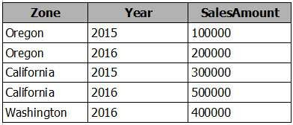

When you attempt to create a map that shows SalesAmount by Zone, you discover that the map shows a bubble based on cities instead of states. You need to ensure that the map shows bubbles based on states.

What should you do?

1. Add a column named Country that contains United States as the value.
2. Add a column for longitude and a column for latitude.
3. Select the Zone field. From the Modeling tab, change the Data Category.
4. Select the Zone field. From the Modeling tab, change the Data Type.

## Correct Answer: C

## QUESTION 15

You have two tables named CustomerVisits and Date in a Power BI model.

You create a measure to calculate the number of customer visits. You use the measure in the report shown in the exhibit. (Click the **Exhibit** button.)

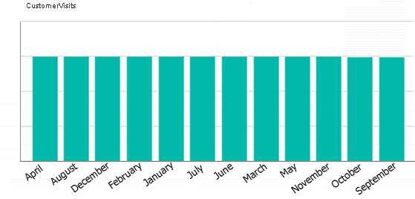

You discover that the total number of customer visits was 60,000, and that there were only 5,000 customer visits in August. You need to fix the report to display the correct data for each month.

What should you do?

1. Modify the measure to use the CALCULATE DAX function.
2. Create a relationship between the CustomerVisits table and the Date table.
3. Modify the measure to use the sum DAX function.
4. Create a hierarchy in the Date table.

## Correct Answer: B

**Section: (none)**

## QUESTION 16

You have the following tables.

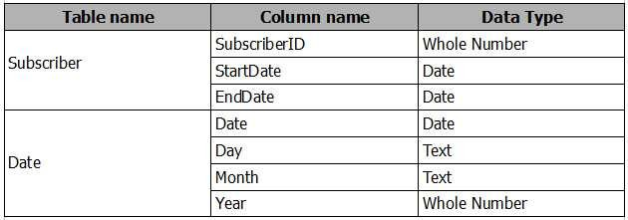

There is a many-to-one relationship from Subscriber to Date that uses Subscriber[StartDate] and Date[Date]. The Cross filter direction of the relationship is set to Single.

You plan to create a column chart that displays the following two measures: Count of SubscriberID by Month based on the StartDate

Count of SubscriberID by Month based on the EndDate What should you do before you create the measures?

1. Create an active one-to-one relationship from Subscriber[StartDate] to Date[Date].
2. Change the Cross filter direction of the active relationship to **Both**.
3. Change the active relationship for many-to-one.
4. Create an inactive many-to-one relationship from Subscriber[StartDate] to Date[Date].

## Correct Answer: B

## QUESTION 17

You have a Power BI report that displays a bar chart and a donut chart on the same page. The bar chart shows the total sales by year and the donut chart shows the total sale by category.

You need to ensure that when you select a year on the bar chart, the donut chart remains unchanged. What should you do?

1. Edit the interactions from the Format menu.
2. Set a visual level filter on the bar chart.
3. Set a visual level filter on the donut chart.
4. Add a slicer to the page that uses the year column.

## Correct Answer: A

## QUESTION 18

**Note: This question is part of a series of questions that use the same scenario. For your convenience, the scenario is repeated in each question. Each question presents a different goal and answer choices, but the text of the scenario is exactly the same in each question in this series.**

**Start of repeated scenario.**

You have a Microsoft SQL Server database that has the tables shown in the Database Diagram exhibit. (Click the **Exhibit** button.)

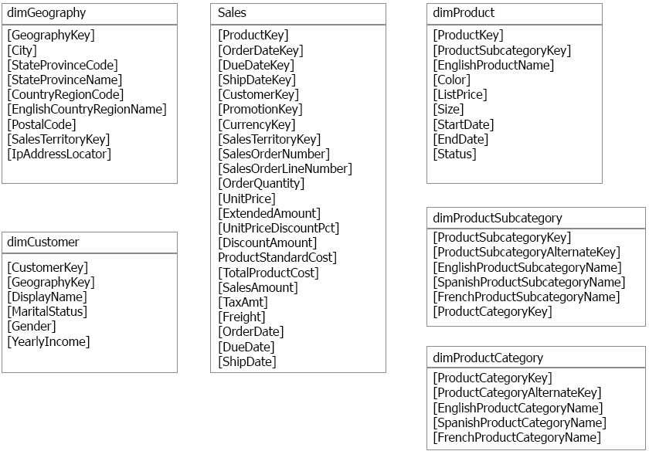

You plan to develop a Power BI model as shown in the Power BI Model exhibit. (Click the **Exhibit** button.)

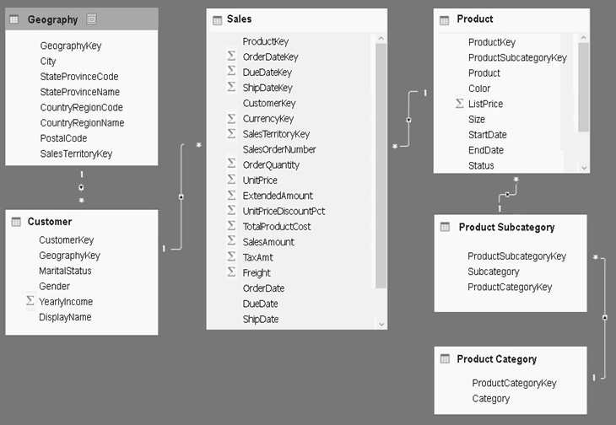

You plan to use Power BI to import data from 2013 to 2015. Product Subcategory[Subcategory] contains NULL values. **End of Repeated Scenario.**

You implement the Power BI model.

You need to add a new column to the Product Subcategory table that uses the following formula.

=if [Subcategory]=null then "NA" else [Subcategory]

Which command should you use in Query Editor?

1. Conditional Column
2. Column From Examples
3. Invoke Custom Function
4. Custom Column

## Correct Answer: A

## QUESTION 19

**Note: This question is part of a series of questions that use the same scenario. For your convenience, the scenario is repeated in each question. Each question presents a different goal and answer choices, but the text of the scenario is exactly the same in each question in this series.**

**Start of repeated scenario.**

You have a Microsoft SQL Server database that has the tables shown in the Database Diagram exhibit. (Click the **Exhibit** button.)



You plan to develop a Power BI model as shown in the Power BI Model exhibit. (Click the **Exhibit** button.)

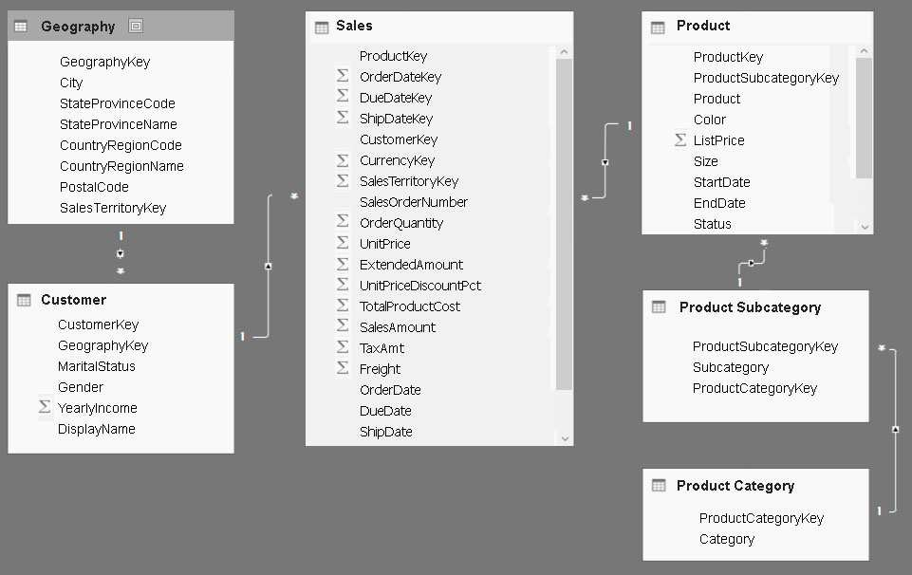

You plan to use Power BI to import data from 2013 to 2015. Product Subcategory[Subcategory] contains NULL values. **End of Repeated Scenario.**

You implement the Power BI model.

You need to add a measure to rank total sales by product. The results must appear as shown in the following table.

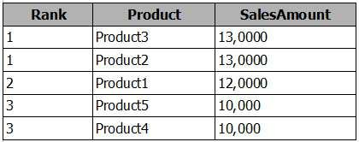

Which DAX formula should you use?

1. Product Ranking = RANKX(ALL('Product'), [SalesAmount],,Asc, Dense)
2. Product Ranking = RANKX(ALL('Product'), [SalesAmount],,DESC, Skip)
3. Product Ranking = RANKX(ALL('Product'), [SalesAmount],,DESC, Dense)
4. Product Ranking = RANKX(Product, [SalesAmount],,DESC, Skip)

## Correct Answer: C

## QUESTION 20

**Note: This question is part of a series of questions that use the same scenario. For your convenience, the scenario is repeated in each question. Each question presents a different goal and answer choices, but the text of the scenario is exactly the same in each question in this series.**

**Start of repeated scenario.**

You have a Microsoft SQL Server database that has the tables shown in the Database Diagram exhibit. (Click the **Exhibit** button.)



You plan to develop a Power BI model as shown in the Power BI Model exhibit. (Click the **Exhibit** button.)



You plan to use Power BI to import data from 2013 to 2015. Product Subcategory[Subcategory] contains NULL values. **End of Repeated Scenario.**

You need to create a measure of Sales[SalesAmount] where Product[Color] is Red or Product[Size] is 50. Which DAX formula should you use?

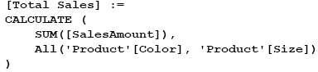A.

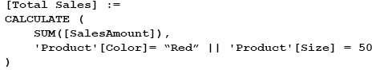B.

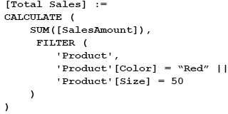C.

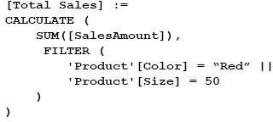D.

## Correct Answer: C

## QUESTION 21

You have two Microsoft SQL Server database servers named SQLProd and SQLDev. SQLDev contains the same tables as SQLProd, but only a subset of the data in SQLProd.

You create a new Power BI Desktop model that uses 120 tables from SQLDev. You plan to publish the Power BI file to the Power BI service.

You need to connect the model to the tables in SQLProd. The solution must minimize administrative effort.

What should you do from Query Editor before you publish the model?

1. Create a new connection to SQLProd, and then import the tables from SQLProd.
2. Delete the existing queries, and then add new data sources.
3. Configure the Data source settings.
4. Edit the source of each table query.

## Correct Answer: D

## QUESTION 22

You have a Power BI model that has a date table. A sample of the data shown in the following table.

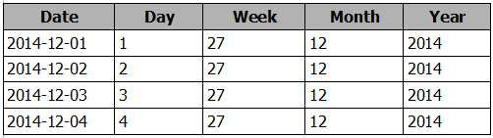

You need to add a column to display the date in the format of December 01, 2014. Which DAX formula should you use in Power BI Desktop?

## FORMAT([Date], "MMM") & " " & FORMAT([Date], "DD") & ", " & FORMAT([Date], "YYYY")

1. **FORMAT([Date], "M") & " " & FORMAT([Date], "D") & ", " & [Date].[Year])**
2. **[Date].[Month] & " " & FORMAT([Date], "D") & ", " & [Date].[Year])**
3. **FORMAT([Date], "MMMM DD, YYYY")**

**Correct Answer:** D

**QUESTION 23**

From Power BI Desktop, you create a query that imports the following table.

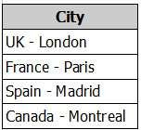

You need to configure the table to appear as shown in the following table:

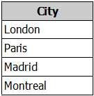

What should you do?

1. From the Format menu, click **Trim**.
2. From the Extract menu, click **Last Characters**.
3. From the Split Column menu, click **By Delimiter**.
4. From the Extract menu, click **Text After Delimiter**.

## Correct Answer: D

## QUESTION 24

You plan to create several datasets by using the Power BI service. You have the files configured as shown in the following table.

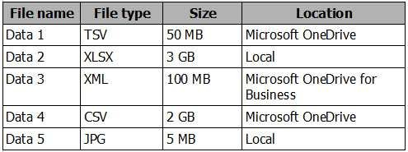

You need to identify which files can be used as datasets.

Which two files should you identify? Each correct answer presents part of the solution.

**NOTE:** Each correct selection is worth one point.

1. Data 1
2. Data 2
3. Data 3
4. Data 4
5. Data 5

## Correct Answer: AE

## QUESTION 25

**Note: This question is part of a series of questions that present the same scenario. Each question in the series contains a unique solution that might meet the stated goals. Some question sets might have more than one correct solution, while others might not have a correct solution.**

**After you answer a question in this section, you will NOT be able to return to it. As a result, these questions will not appear in the review screen.**

You have an app workspace that contains a report. The report contains sensitive data.

You need to ensure that you can embed the report into a custom application that will be accessed by external users. The external users will **NOT** have a Microsoft Azure Active Directory user account or Power BI licenses.

Solution: From Publish to web, generate an iFrame. Does this meet the goal?

1. Yes
2. No

## Correct Answer: B

**QUESTION 26**

**Note: This question is part of a series of questions that present the same scenario. Each question in the series contains a unique solution that might meet the stated goals. Some question sets might have more than one correct solution, while others might not have a correct solution.**

**After you answer a question in this section, you will NOT be able to return to it. As a result, these questions will not appear in the review screen.**

You have an app workspace that contains a report. The report contains sensitive data.

You need to ensure that you can embed the report into a custom application that will be accessed by external users. The external users will **NOT** have a Microsoft Azure Active Directory user account or Power BI licenses.

Solution: Configure the app workspace to be read-only for members and to run in a shared capacity. Does this meet the goal?

1. Yes
2. No

## Correct Answer: B

**QUESTION 27**

**Note: This question is part of a series of questions that present the same scenario. Each question in the series contains a unique solution that might meet the stated goals. Some question sets might have more than one correct solution, while others might not have a correct solution.**

**After you answer a question in this section, you will NOT be able to return to it. As a result, these questions will not appear in the review screen.**

You have a Microsoft Excel workbook that is saved to Microsoft SharePoint Online. The workbook contains several Power View sheets. You need to recreate the Power View sheets as reports in the Power BI service.

Solution: From Excel, click **Publish to Power BI**, and then click **Export**. Does this meet the goal?

1. Yes
2. No

## Correct Answer: B

**QUESTION 28**

Your company has several developers who plan to create custom solutions that will interact with the API for the Power BI service. Which three operations can the developers achieve by using the API? Each correct answer presents a complete solution.

**NOTE**: Each correct selection is worth one point.

1. Retrieve rows from a dataset
2. Create a dataset
3. Add rows to a dataset
4. Refresh an imported dataset
5. Add a member to a row-level security role

## Correct Answer: ABC

**QUESTION 29**

You have a service published to a website.

When you connect to the website, you receive the following data.

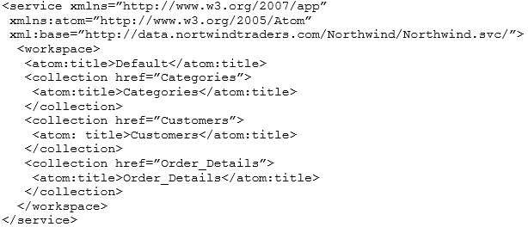

You need to create a query that retrieves the Categories data and the Customers data. Which type of source should you use?

1. JSON
2. Text/CSV
3. OData Feed
4. XML

## Correct Answer: D

**QUESTION 30**

You are importing sales data from a Microsoft Excel file named Sales.xlsx into Power BI Desktop. You need to create a bar chart showing the total sales amount by region.

When you create the bar chart, the regions appear as expected, but the sales amount value displays the count of sales amount instead of the sum of sales amount each region.

You need to modify the query to ensure that the data appears correctly. What should you do?

1. Delete the query, import the data into Microsoft SQL Server, and then import the data from SQL Server.
2. In Query Editor, add a calculated column that totals the sales amount column.
3. Change the Data Type of sales amount column to **Numeric.**
4. Refresh the data model.

## Correct Answer: B

**QUESTION 31**

You create a KPI visualization in Power BI Desktop that uses the month as the trend axis. You discover that the data is not sorted by month.

You need to change the sort order of the visualization. What should you do first?

1. Convert the visualization to a different type.
2. Remove the trend axis from the visualization.
3. Modify the visual level filters.
4. Modify the drillthrough filters.

## Correct Answer: B

**QUESTION 32**

You have a query that retrieves sales data. A sample of the data is shown in the following table.

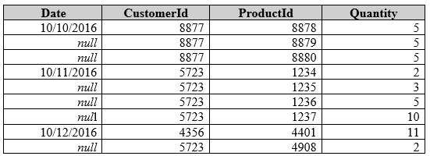

You need to ensure that the values in the Date column contain a date. Null values must be replaced with the date from the previous row. What should you click on the Transform tab in Query Editor?

1. **Forma**t, and then **Clean**
2. **Date**, and then **Earliest**
3. **Fill**, and then **Down**
4. **Replace Values**, and then **Replace Errors**

## Correct Answer: C

## QUESTION 33

Your organization has a Microsoft Office 365 subscription.

When the users attempt to access the Power BI Service, they receive the error message shown in the exhibit. (Click the **Exhibit** button.)

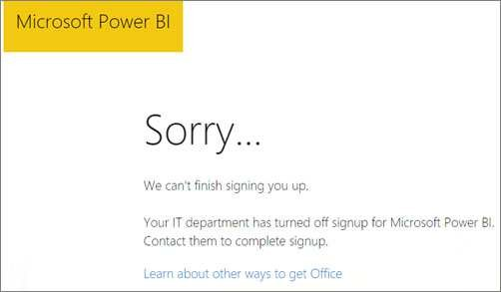

You need to ensure that all the users can access the Power BI service. What should you do first?

1. From the Microsoft Azure Active Directory admin center, assign a Power BI (free) license to each user.
2. From the Power BI Admin portal, modify the Tenant settings.
3. From Microsoft Azure PowerShell, run the Set-MsolCompanySettings cmdlet.
4. From the properties of each dashboard, modify the Share dashboard settings.

## Correct Answer: C

## QUESTION 34

You plan to use Power BI Desktop to import 100 CSV files.

The files contain data from different stores. The files have the same structure and are stored in a network share. You need to import the CSV files into one table. The solution must minimize administrative effort.

What should you do?

1. Add a folder data source and use the **Combine Files** command.
2. Add a folder data source and use the **Merge Queries** command.
3. Add a Microsoft Excel data source and use the **Merge Queries** command.
4. Add text/CSV data sources and use the **Append Queries** command.

## Correct Answer: A

## QUESTION 35

You have a Power BI app named App1. The privacy for the App1 app workspace is set to Private.

A user named User1 reports that App1 does not appear in the My organization AppSource. App1 appears in the My organization AppSource for your account. You need to ensure that User1 sees App1 from the My organization AppSource.

What should you do?

1. From the app workspace, click Update app, configure the Access setting, and then click Update app.
2. From the app workspace, share the dashboard.
3. From the app workspace settings, add a member.
4. From the app workspace, click Update app, configure the Content settings, and then click Update app.

## Correct Answer: A

**QUESTION 36**

You have a sales report in an app workspace. The report displays a map of sales by location and a bar chart of sales by year. The report has a slicer to filter the data by year.

You need to create a dashboard that contains visualizations. The solution must ensure that you can use the slicer to filter the data by year. What should you do?

1. Pin each visualization to the dashboard, and then add a web content tile.
2. Add a page level filter, and then pin each visualization to the dashboard.
3. Publish the app workspace.
4. Pin the report as a live page.

## Correct Answer: D

## QUESTION 37

A data analyst publishes several Power BI visualizations to a blog.

You discover that some of the visualizations contain data that is considered private by your company. You need to prevent the visualizations from being published to the blog.

What should you do?

1. From the Power BI Admin portal, disable the Publish to web setting.
2. From the Power BI settings, delete the embedded codes.
3. From the Power BI Admin portal, disable the Share content with external users setting.
4. From the dashboard settings, modify the Share dashboard settings.

## Correct Answer: A

## QUESTION 38

You have an app workspace that contains two datasets named dataset1 and dataset2. Dataset1 connects to a Microsoft Azure SQL database. Dataset2 connects to a Microsoft Excel file stored in Microsoft OneDrive for Business.

You create a report named Report1 that uses dataset1. You pin Report1 to a dashboard named Dashboard1.

You publish the app workspace to all the users in your organization. You need to delete dataset2 from the app workspace.

What should you do first?

1. Delete Dashboard1.
2. Delete Report1.
3. Unpublish the app.
4. Configure the refresh settings for Dataset2.

## Correct Answer: C

**QUESTION 39**

In the Power BI service, you create an app workspace that contains several dashboards.

You need to provide a user named [user1@contoso.com](mailto:user1@contoso.com) with the ability to edit and publish dashboards.

What should you do?

1. Modify the members of the app workspace.
2. Configure security for the dataset used by the app.
3. Share the dashboard, and then modify the Access settings of the dashboard.
4. From the app workspace, click Update app, and then configure the Access settings.

## Correct Answer: C

**QUESTION 40**

You embed a Power BI report in a Microsoft SharePoint Online page.

A user named User1 can access the SharePoint Online page, but the Power BI web part displays the following error message: “This content isn’t available.” User1 is unable to view the report.

You verify that you can access the SharePoint Online page and that the Power BI report displays as expected. You need to ensure that User1 can view the report from SharePoint Online.

What should you do?

1. Publish the app workspace.
2. Share the dashboard in the app workspace.
3. Edit the settings of the Power BI web part.
4. Modify the members of the app workspace.

## Correct Answer: A

**QUESTION 41**

**Note: This question is part of a series of questions that present the same scenario. Each question in the series contains a unique solution that might meet the stated goals. Some question sets might have more than one correct solution, while others might not have a correct solution.**

**After you answer a question in this section, you will NOT be able to return to it. As a result, these questions will not appear in the review screen.**

You have a query for a table named Sales. Sales has a column named CustomerID. The Data Type of CustomerID is Whole Number. You refresh the data and find several errors. You discover that new entries in the Sales table contain nonnumeric values.

You need to ensure that nonnumeric values in the CustomerID column are set to 0. Solution: From Query Editor, select the CustomerID column and click **Remove Errors.** Does this meet the goal?

1. Yes
2. No

## Correct Answer: B

**QUESTION 42**

You have a Power BI model for sales data. You create a measure to calculate the year-to-date sales. You need to compare the year-to-date sales with the previous year for the same time period.

Which DAX function should you use?

1. LASTDATE
2. TOTALYTD
3. SAMEPERIODLASTYEAR
4. PREVIOUSYEAR

## Correct Answer: C

**QUESTION 43**

From the Home tab in Power BI Desktop, you click **Enter Data** and create a table named Sales that contains the following data.

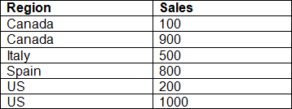

You add Region and Sales to visualization and the visualization displays the following data.

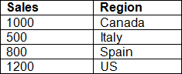

What causes the visualization to display four rows of data instead of six?

1. the Data Category of Region
2. the Default Summarization on Region
3. the Default Summarization on Sales
4. the Data Category of Sales

## Correct Answer: B

**QUESTION 44**

You have a table named Sales. A sample of the data in Sales is shown in the following table.

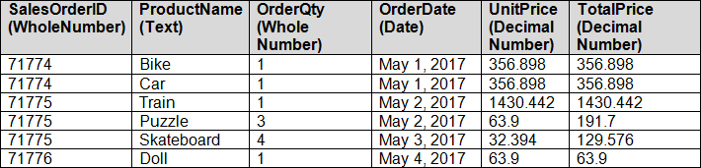

You create a stacked column chart visualization that displays ProductName by Date. You discover that the axis for the visualization displays all the individual dates.

You need to ensure that the visualization displays ProductName by year and that you can drill down to see ProductName by week and day. What should you do first?

1. Create a new table that has columns for the date, year, week, and day.
2. Create a new hierarchy in the Sales table.
3. Format the visualization and set the type of the X-Axis to **Categorical**.
4. Configure a visual filter for the Date column that uses an advanced filter.

## Correct Answer: A

**QUESTION 45**

You need to create a custom visualization for Power BI. What should you install first?

1. jQuery
2. Node.js
3. Microsoft Azure PowerShell
4. Microsoft.NET

## Correct Answer: B

## QUESTION 46

You are creating a report in Power BI Desktop that has two visualizations on a page as shown in the following exhibit.

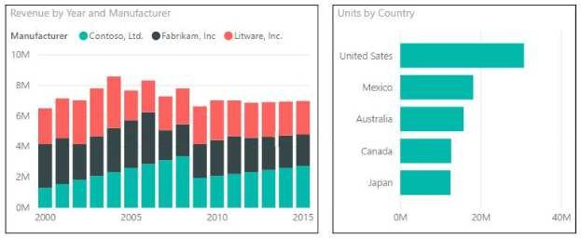

You need to ensure that when you click the bar of a country, only the values for that country are shown on the Revenue by Year and Manufacturer chart.

1. Click the **Revenue by Year and Manufacturer** chart. On the Format tab, click **Edit Interactions**. On the Units by Country chart, click **Filter**.
2. Click the **Revenue by Year and Manufacturer** chart. On the Format tab, click **Edit Interactions**. On the Units by Country chart, click **Highlight**.
3. Click the **Units by Country** chart. On the Format tab, click **Edit Interactions**. On the Revenue by Year and Manufacturer chart, click **Filter**.
4. Click the **Units by Country** chart. On the Format tab, click **Edit Interactions**. On the Revenue by Year and Manufacturer chart, click **Highlight**.

## Correct Answer: C

## QUESTION 47

Your company has a security policy stating that proprietary data must not be transferred over the Internet. During a security audit, auditors discover that executives use the Power BI service for reporting.

You need to recommend a solution to ensure that the company adheres to the security policy.

What should you include in the recommendation?

1. Microsoft SQL Server column encryption
2. Microsoft Azure ExpressRoute
3. a site-to-site VPN to Microsoft Azure
4. the on-premises gateway for Power BI

## Correct Answer: B

## QUESTION 48

**Note: This question is part of a series of questions that use the same scenario. For your convenience, the scenario is repeated in each question. Each question presents a different goal and answer choices, but the text of the scenario is the same in each question in this series.**

You have a Microsoft SQL Server database that contains the following tables.

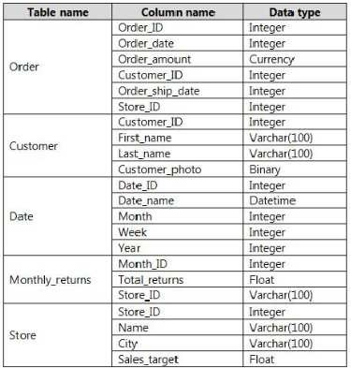

The following columns contain date information:

Date[Month] in the mmyyyy format Date[Date_ID] in the ddmmyyyy format Date[Date_name] in the mm/dd/yyyy format Monthly_returns[Month_ID] in the mmyyyy format

The Order table contains more than one million rows.

The Store table has a relationship to the Monthly_returns table on the Store_ID column. This is the only relationship between the tables. You plan to use Power BI Desktop to create an analytics solution for the data.

You need to create a chart that displays a sum of Order[Order_amount] by month for the Order_ship_date column and the Order_date column.

How should you model the data?

1. Create a one-to-many relationship from Date[Date_ID] to Order[Order_date] and another relationship from Date[Date_ID] to Monthly_returns[Date_ID].
2. Add a second Date table named Ship_date to the model. Create a many-to-many relationship from Date[Date_ID] to Order[Order_date] and many-to-many relationship from Ship_date[Date_ID] to Order[Order_ship_date].
3. Add a second Date table named Ship_date to the model. Create a one-to-many relationship from Date[Date_ID] to Order[Order_date] and a one-to-many relationship from Ship_Date[Date_ID] to Order[Order_ship_date].
4. Create a one-to-many relationship from Date[Date_ID] to Order[Order_date] and another relationship from Date[Date_ID] to Order[Order_ship_date].

## Correct Answer: C

**QUESTION 49**

You plan to create a dashboard in the Power BI service that retrieves data from a Microsoft SQL Server database. The dashboard will be shared between the users in your organization.

You need to ensure that the users will see the current data when they view the dashboard. How should you configure the connection to the data source?

1. Deploy an on-premises data gateway. Connect to the data by using the Import Data Connectivity mode.
2. Deploy an on-premises data gateway. Connect to the data by using the DirectQuery Data Connectivity mode.
3. Deploy an on-premises data gateway (personal mode). Connect to the data by using the Import Data Connectivity mode.
4. Deploy an on-premises data gateway (personal mode). Connect to the data by using the DirectQuery Data Connectivity mode.

## Correct Answer: B

**QUESTION 50**

You plan to use Power BI Desktop optimized for Power BI Report Server to create a report. The report will be published to Power BI Report Server. You need to ensure that all the visualization in the report can be consumed by users.

Which three types of visualizations should you include in the report? Each correct answer presents part of the solution.

**NOTE:** Each correct selection is worth one point.

1. bubble maps
2. custom visuals
3. R visuals
4. breadcrumbs
5. funnel charts

## Correct Answer: ABE

## QUESTION 51

You plan to use Power BI Desktop to create a report. The report will consume data from an on-premises tabular database named SalesDB in Microsoft SQL Server Analysis Services (SSAS). The report will be published to the Power BI service.

You need to ensure that the report published to the Power BI service will access the current data in SalesDB. What should you do?

1. Deploy an on-premises data gateway and configure the connection to SalesDB to use the Connect live option.
2. Deploy an on-premises data gateway and configure the connection to SalesDB to use the Import Data Connectivity mode.
3. Deploy an on-premises data gateway (personal mode) and configure the connection to SalesDB to use the DirectQuery Data Connectivity mode.
4. Deploy an on-premises data gateway and configure the connection to SalesDB to use the DirectQuery Data Connectivity mode.

## Correct Answer: A

**QUESTION 52**

You plan to join a fact table named ActivityLog to a Date dimension named ActivityDate. The date value in ActivityLog is a datetime column named ActivityStart. The date value in ActivityDate is a number column named DateID. DateID is in the YYYYMMDD format.

What should you do in the model before you create the relationship?

1. Change the Data Type of ActivityStart to Date.
2. Create a measure in ActivityLog that uses the FORMAT DAX function.
3. Change the Data Type of DateID to Date.
4. Create a calculated column in ActivityLog that uses the FORMAT DAX function.

## Correct Answer: D

**QUESTION 53**

You have a table in Power BI Desktop as shown in the following exhibit.

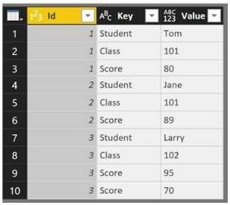

You pivot the columns as shown in the following exhibit.

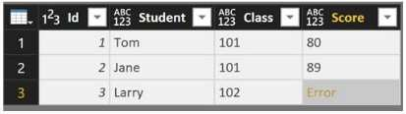

You need to resolve the error in row 3. The solution must preserve all the data. What should you do?

1. Change the Data Type of the Value column.
2. Select the Key column, and then click **Remove Duplicates**.
3. Change the Aggregate Value Function of the pivot.
4. Select the Score column, and then click **Remove Errors**.

## Correct Answer: C

**QUESTION 54**

You attempt to publish a Microsoft Excel file to Power BI, and you receive the error message shown in the exhibit. (Click the **Exhibit** button.)

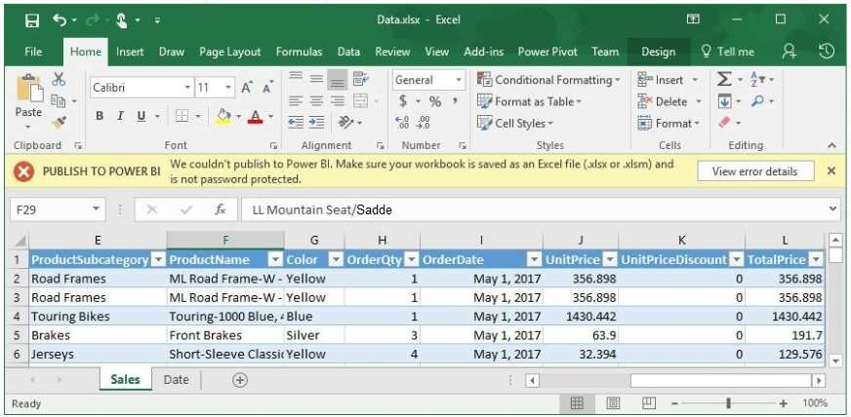

The file is in c:\data\.

You need to ensure that you can publish the file to Power BI. What should you do first?

1. Save the file in a Microsoft SharePoint document library.
2. Decrypt the workbook.
3. Add a digital signature to the workbook.
4. Set the file attributes to read-only.

## Correct Answer: B

## QUESTION 55

You have two tables named Customer and Orders. A sample of the Data in Customer is shown in the following table.

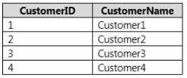

A sample of the data in Orders is shown in the following table.

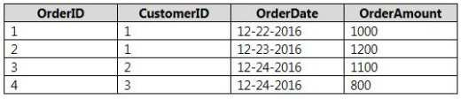

You need to create the following new table.

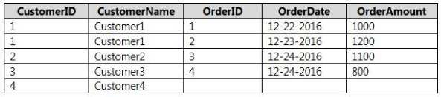

You must use Customer as the first table. Which join kind should you use?

1. Right Anti
2. Right Outer
3. Left Anti
4. Left Outer
5. Inner

## Correct Answer: D

**QUESTION 56**

**Note: This question is part of a series of questions that present the same scenario. Each question in the series contains a unique solution that might meet the stated goals. Some question sets might have more than one correct solution, while others might not have a correct solution.**

**After you answer a question in this section, you will NOT be able to return to it. As a result, these questions will not appear in the review screen.**

Your company has 1,000 users in a Microsoft Office 365 subscription.

A Power BI administrator named Admin1 creates 20 dashboards and shares them with 50 users. You discover that a user named User1 can access all the dashboards.

You need to prevent User1 from accessing all the dashboards.

Solution: From the properties of each dashboard, you modify the Share settings. Does this meet the goal?

1. Yes
2. No

## Correct Answer: A

## QUESTION 57

**Note: This question is part of a series of questions that present the same scenario. Each question in the series contains a unique solution that might**

**meet the stated goals. Some question sets might have more than one correct solution, while others might not have a correct solution.**

**After you answer a question in this section, you will NOT be able to return to it. As a result, these questions will not appear in the review screen.**

Your company has 1,000 users in a Microsoft Office 365 subscription.

A Power BI administrator named Admin1 creates 20 dashboards and shares them with 50 users. You discover that a user named User1 can access all the dashboards.

You need to prevent User1 from accessing all the dashboards.

Solution: From the Power BI Admin portal, you modify the Dashboard settings. Does this meet the goal?

1. Yes
2. No

## Correct Answer: B

**QUESTION 58**

**Note: This question is part of a series of questions that present the same scenario. Each question in the series contains a unique solution that might meet the stated goals. Some question sets might have more than one correct solution, while others might not have a correct solution.**

**After you answer a question in this section, you will NOT be able to return to it. As a result, these questions will not appear in the review screen.**

Your company has 1,000 users in a Microsoft Office 365 subscription.

A Power BI administrator named Admin1 creates 20 dashboards and shares them with 50 users. You discover that a user named User1 can access all the dashboards.

You need to prevent User1 from accessing all the dashboards.

Solution: From the Office 365 Admin center, you remove the Power BI license from User1.

Does this meet the goal?

1. Yes
2. No

## Correct Answer: B

**QUESTION 59**

You create a dashboard that displays the results of a customer satisfaction survey. You need to embed a tweet from your company’s Twitter feed into the dashboard. What should you do?

1. Edit the report and import a visualization from the marketplace. Pin the visualization to the dashboard.
2. Edit the report and import a visualization from a file. Pin the visualization to the dashboard.
3. To the dashboard, add a tile that uses a web content source.
4. To the dashboard, add a tile that uses a PubNub content source.

## Correct Answer: C

## QUESTION 60

**Note: This question is part of a series of questions that use the same scenario. For your convenience, the scenario is repeated in each question. Each question presents a different goal and answer choices, but the text of the scenario is the same in each question in this series.**

You have a Microsoft SQL Server database that contains the following tables.

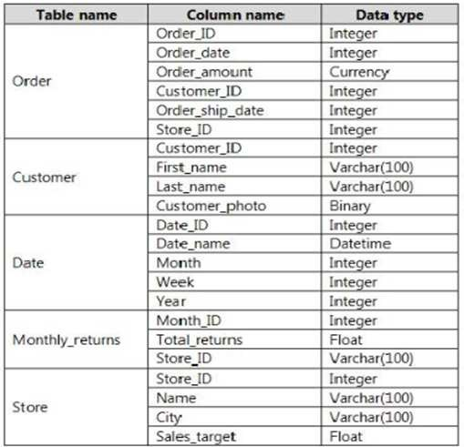

The following columns contain date information:

* Date[Month] in the mmyyyy format
* Date[Date_ID] in the ddmmyyyy format
* Date[Date_name] in the mm/dd/yyyy format
* Monthly_returns[Month_ID] in the mmyyyy format The Order table contains more than one million rows.

The Store table has a relationship to the Monthly_returns table on the Store_ID column. This is the only relationship between the tables. You plan to use Power BI Desktop to create an analytics solution for the data.

You need to create a relationship between the Monthly_returns table and Date[Date_ID]. What should you do before you create the relationship?

1. In the Date table, create a new calculated column named Month_ID that uses the yyyydd format.
2. In the Monthly_returns table, create a new calculated column named Date_ID that uses the ddmmyyyy format.
3. To the Order table, add a calculated column that uses the RELATED(Monthly_returns[Month_ID]) DAX formula.
4. To the Date table, add a calculated column that uses the RELATED(Monthly_returns[Month_ID]) DAX formula.

Correct Answer: B